TheShield HD Worship Center Contribution Receipt (Cash Only)

Contribution Statement for the Year of 20___

TheShield HD Worship Center
281 East Wright Street
Winder, GA 30680
info@theshield.ch

Name: _____________________________________________

For the calendar year of 20____, our records indicate that you made the following cash contributions. Should you have any questions about any amount reported or not reported on this statement, please notify the church treasurer within 60 days of the date of this statement. Statements that are not questioned within 60 days will be assumed to be accurate.

Dates General Fund Building Fund Other

___/___/_____ - ___/___/_____ $ ___________ $ ___________ $ ___________

Total Contributions $ ___________

No goods or services were provided to you by the church in connection with any contribution, or their value was insignificant or consisted entirely of intangible religious benefits.

God Bless You For Your Continued Support:

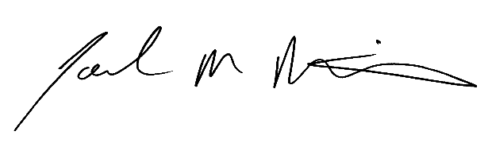

Pastor Joel M. Martin

TheShield HD Worship Center is a part of The Congregational Holiness Church, Inc., and is a "charitable organization" as defined by Internal Revenue Code 501(c)(3), Tax ID # 58-1643352

